A SonarQube instance comprises three components:

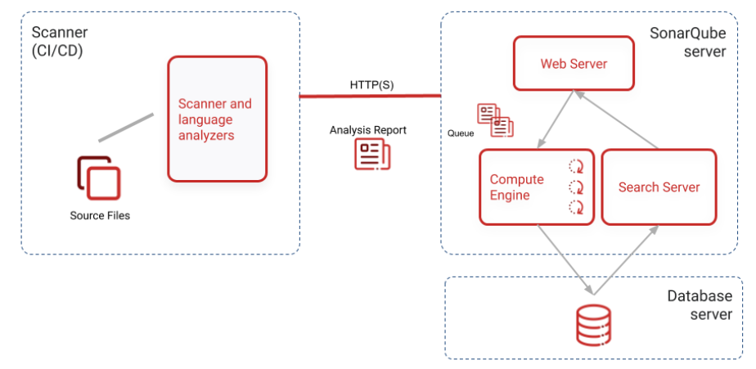

1. The SonarQube server running the following processes:
   * a web server that serves the SonarQube user interface.
   * a search server based on Elasticsearch.
   * the compute engine in charge of processing code analysis reports and saving them in the SonarQube database.
2. The **database** to store the following:
   * Metrics and issues for code quality and security generated during code scans.
   * The SonarQube instance configuration.
3. One or more scanners running on your build or continuous integration servers to analyze projects.

SonarQube will store the code quality reports in database.

Pre-requisites

Documentation link: <https://docs.sonarqube.org/latest/>

Select the SonarQube version to be installed.

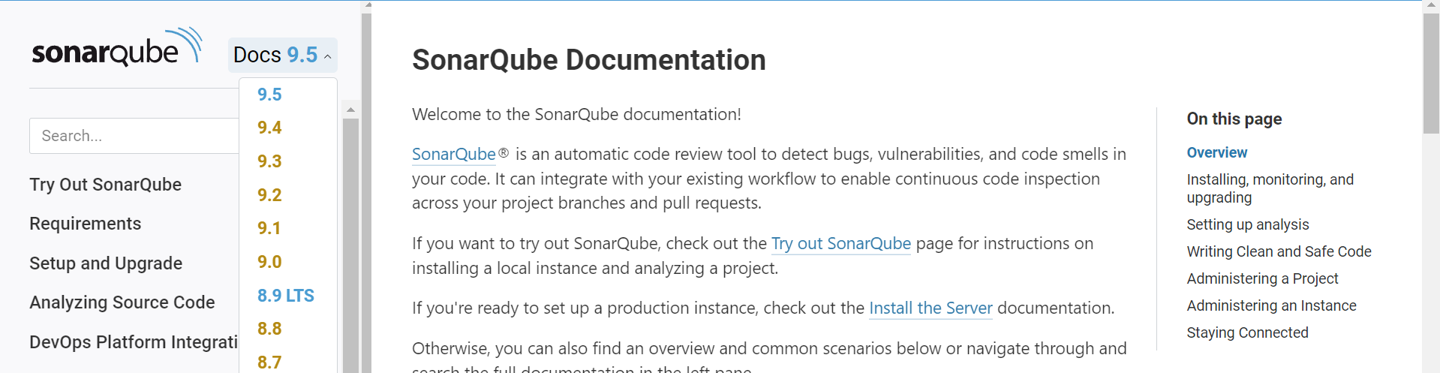

Once selected the version check the pre-requisites required and their version for the selected SonarQube version.

Installing SonarQube on Ubuntu

I am going to install SonarQube 9.5 version,

First, check the pre-requisites version like java, databases.

So, I want to continue with installing of JAVA-11 and Postgres-11 versions.

**Installing Java-11:**

* sudo apt install openjdk-11-jdk

**Installing Linux util Packages:**

* sudo apt install wget
* sudo apt install unzip

**Installing SonarQube 9.5:**

* wget <https://binaries.sonarsource.com/Distribution/sonarqube/sonarqube-9.5.0.56709.zip>

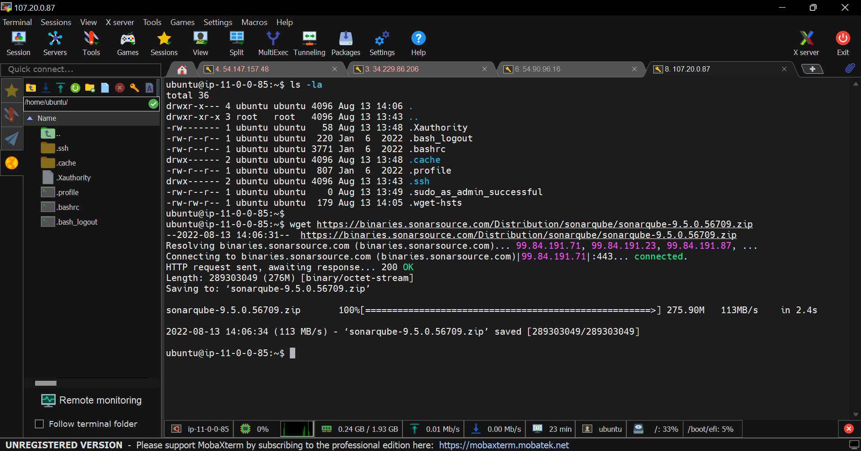

Unzip the zip file.

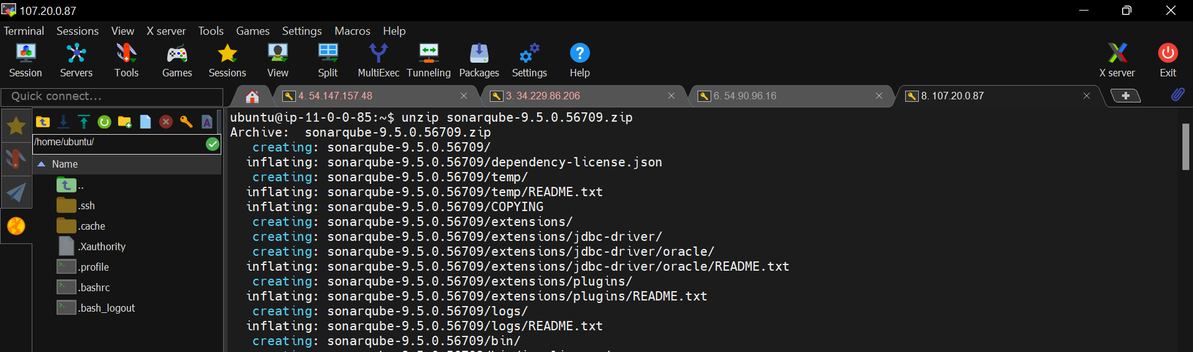

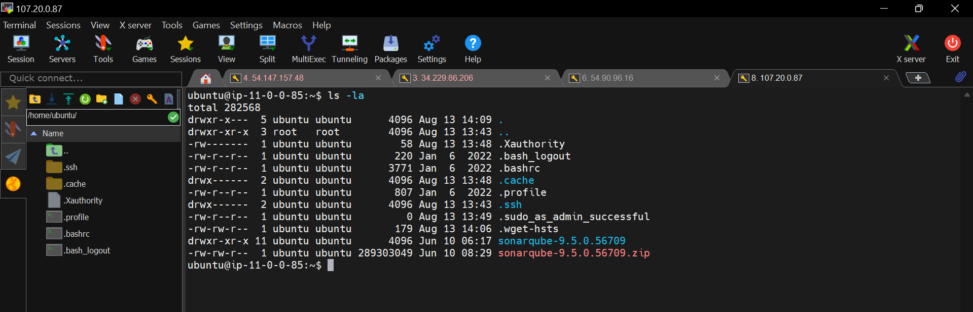

Now, move this extracted file to /opt directory.

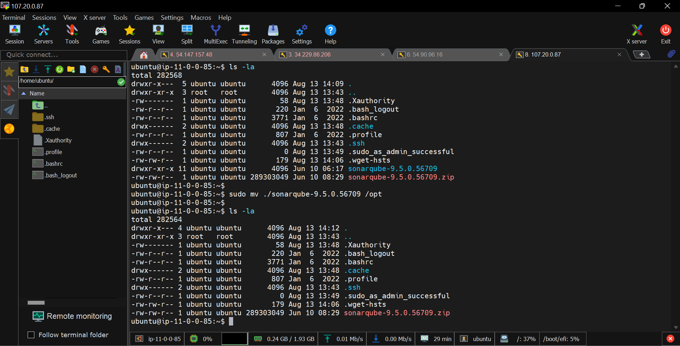

Now, change the directory to /opt

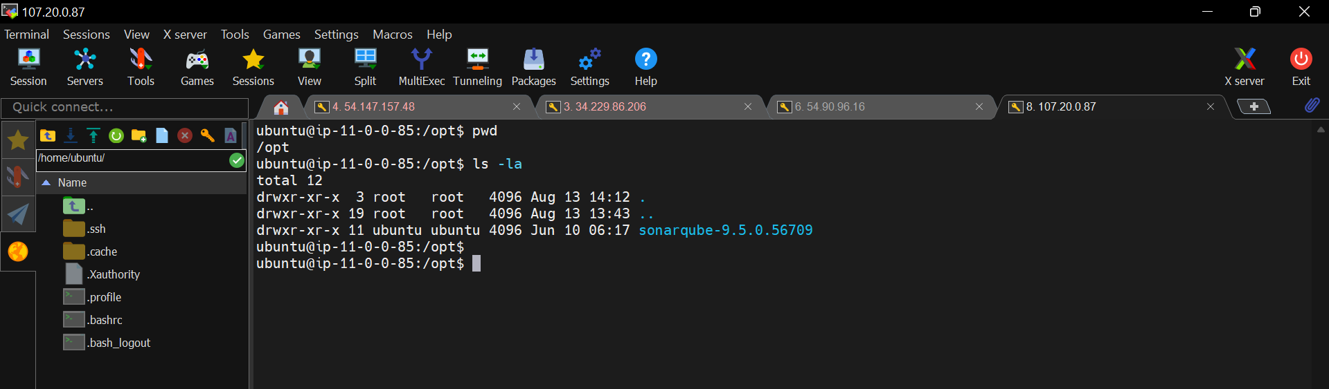

Check the directories and files inside the SonarQube installation directory.

Bin 🡺 binaries to run the SonarQube server

Conf 🡺 SonarQube configuration files

Logs 🡺 SonarQube server logs directory.

Lib 🡺 Libraries to run the SonarQube by binaries in bin directory.

Now, start the SonarQube server.

* cd bin

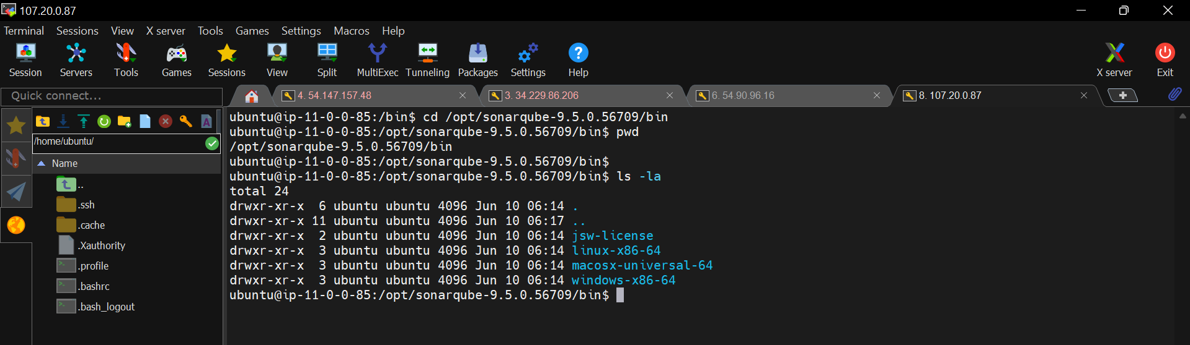

Go to linux-x86-64 directory for linux binaries.

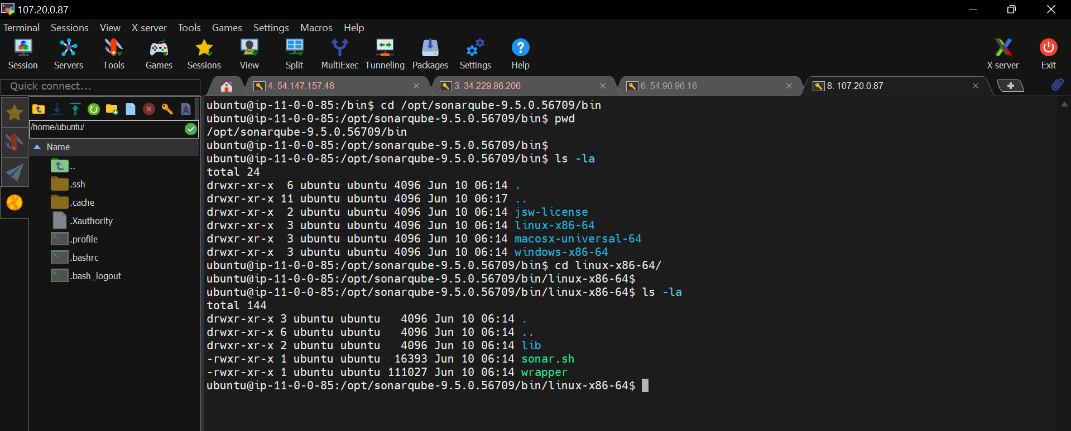

Run the sonar.sh file to start the server

* ./sonar.sh start # To start the server.

Check the status now.

* ./sonar.sh status

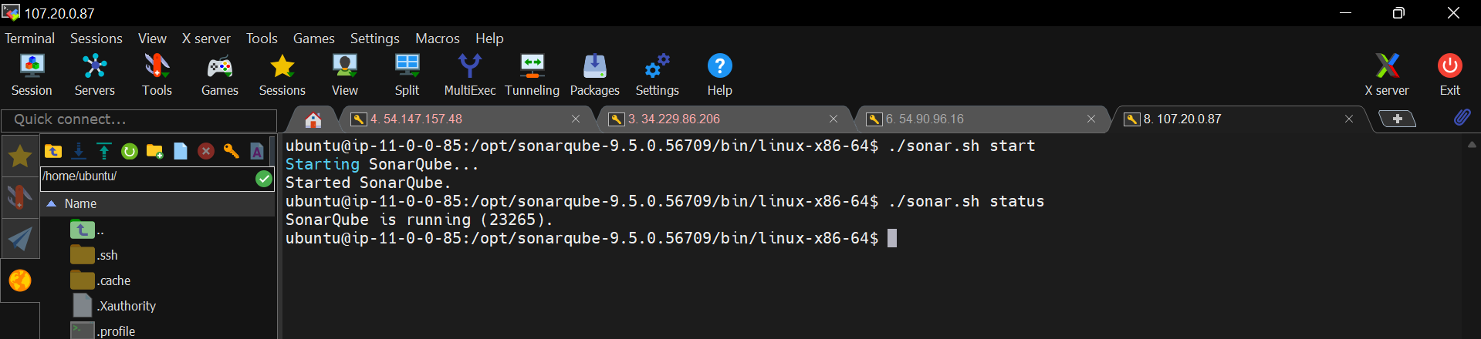

./sonar.sh start # to start the server

./sonar.sh stop # to stop the server

./sonar.sh restart # to restart the server

./sonar.sh status # to check the status

Now, open the server in browser

Copy the instance public id

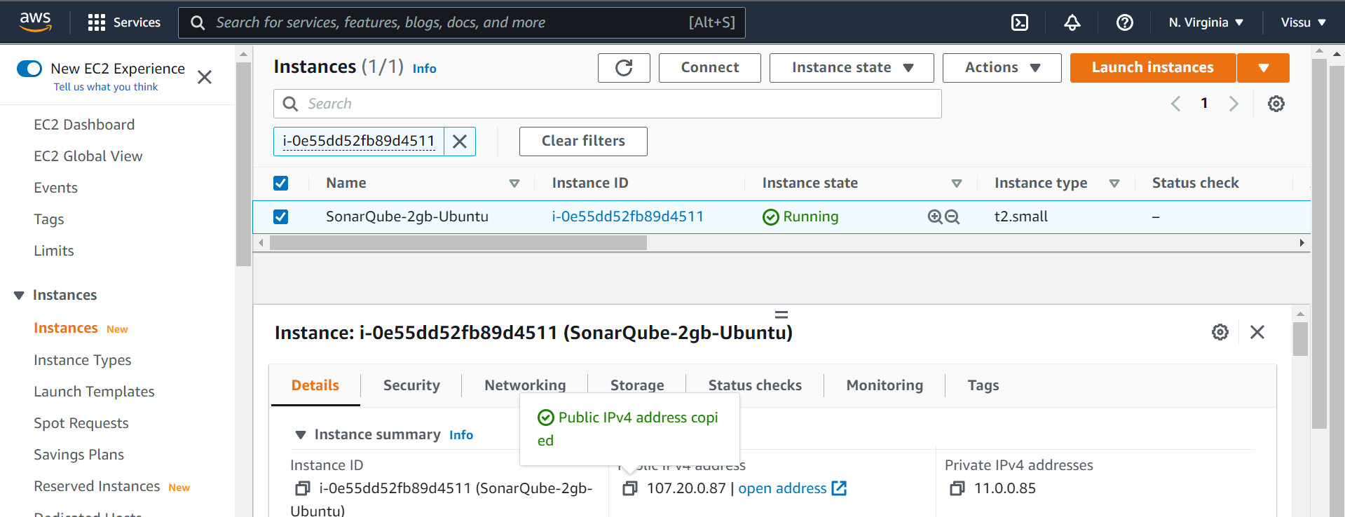

Open browser and pasted like this

<http://public-ip:9000> # 9000 is the default port number for SonarQube server.

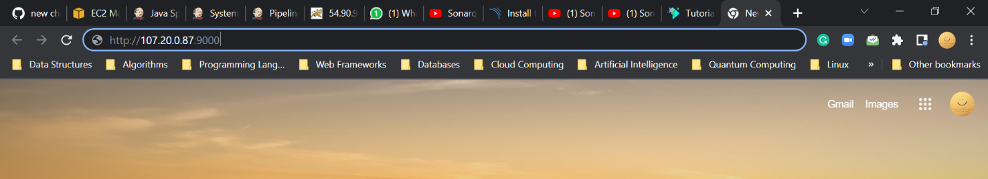

Click on enter

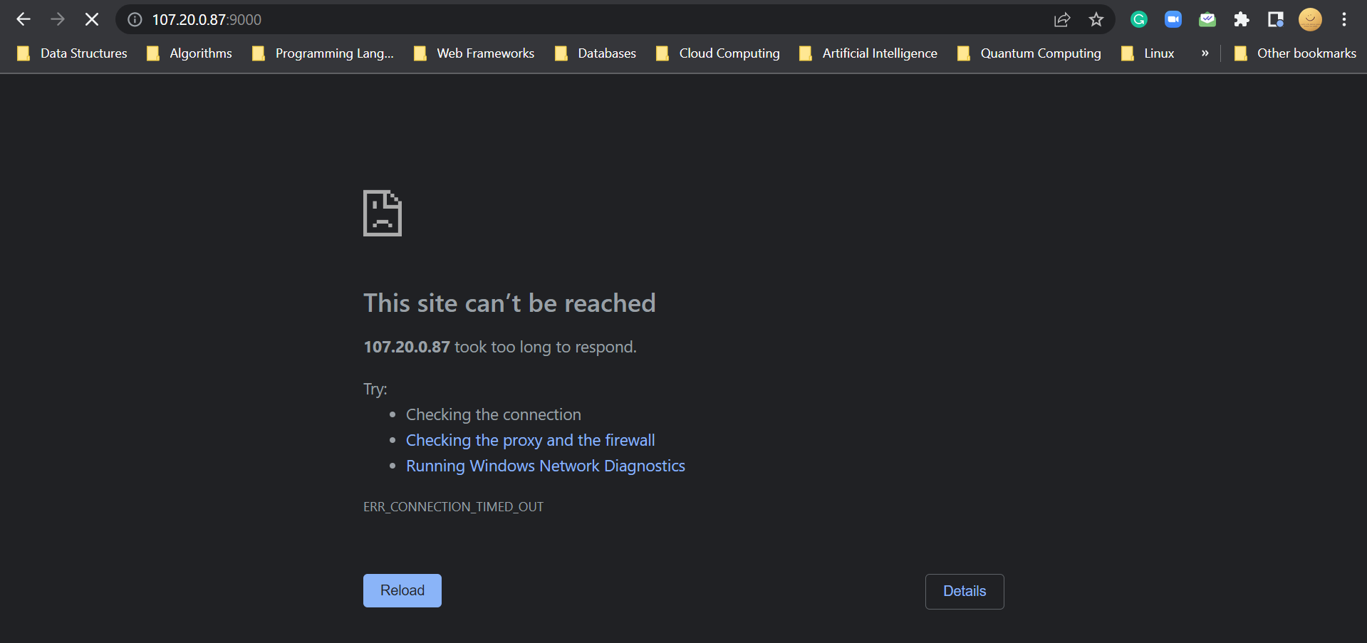

If you are getting this error, then check your instance security group inbound rules.

Click on Edit Inbound Rules

Check if the port number 9000 is allowed or not. If not allow it.

Now, go to browser and refresh it once.

Now, the SonarQube server is loaded.

Login to the server with default credentials

Default username = admin

Default password = admin

It will ask to reset the default password because of security. Please reset the admin credentials for safe security.

Click on “update”.

Finally, we are able to login to the SonarQube server successfully.